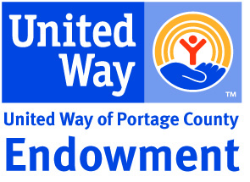

Case Statement
The United Way of Portage County Endowment provides funding to serve the most current, critical needs of our community’s most vulnerable populations with programs that provide measurable results.
*APPROVED 7/26/23 BY ENDOWMENT COMMITTEE

Spending Plan
Using a 12-quarter rolling average based on the total balances in fixed income and equities at the end of each quarter, up to 5% of the rolling average will be recommended by the Endowment and Finance Committees to address current, critical needs of our community as approved by the United Way of Portage County Board of Directors.
*APPROVED 7/26/23 BY ENDOWMENT COMMITTEE
**APPROVED 10/4/2023 BY ENDOWMENT COMMITTEE VIA EMAIL

